Data Mining
It is a technical methodology that identifies patterns, rules, or trends that contextually explain data behaviour.

Features
- Automatic or semi-automatic process
- Uses mathematical techniques
- Uses statistical methods
- Uses machine learning approaches
- Uses artificial intelligence (AI)
- Identifies patterns and trends that were previously impossible to find using traditional data exploration techniques
- Practical and convenient for handling enormous amounts of data

Process of Data Mining

1. Data Collection and Integration
The process starts with gathering large amounts of data from various sources such as transactional databases, data warehouses, or even the web. This data is then integrated to create a dataset for analysis.

2. Data Preprocessing
This step includes removing noise, handling missing values, and transforming data into a suitable format for analysis.

3. Pattern Recognition and Machine Learning
These techniques are used to identify patterns, correlations, and trends within the data. Machine learning algorithms such as clustering, classification, and regression help uncover hidden insights that drive decision-making.

4. Statistical Analysis
Statistics is used to understand how different factors are related, how strong those relationships are, and whether the patterns observed are meaningful or not.

5. Evaluation and Interpretation
After patterns are identified, it is important to check how relevant and significant they are. The results are presented through visualizations or reports to help businesses understand the data and make informed decisions.

6. Data Presentation and Visualization
It is very important to share the findings clearly. Visualization tools such as graphs, charts, and dashboards are used to present the insights in an easily understandable format.

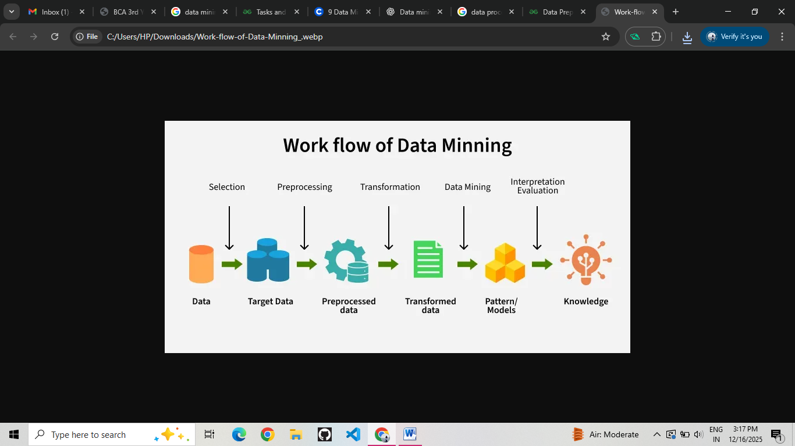

Applications of Data Mining
- Fraud Detection: Helps identify fraudulent activities by detecting unusual transaction patterns in banking and insurance.
- Anomaly Detection: Finds abnormal patterns that differ from normal behavior, often used in security and system monitoring.
- Supply Chain Optimization: Improves inventory control, demand forecasting, and logistics efficiency.
- Traffic Management: Uses traffic data to predict congestion and improve traffic flow and safety.
- Financial Market Analysis: Analyzes market trends to support investment decisions and risk management.

Advantages of Data Mining
- Automates tasks and improves efficiency.
- Helps detect fraud and unusual activities.
- Supports better risk management and compliance.
- Improves decision-making and resource use.

Disadvantages of Data Mining
- Poor data quality affects results.
- Privacy and security risks exist.
- Models may overfit or underfit data.
- Handling large datasets is difficult.
- Bias can lead to unfair outcomes.

Types of Data Mining Techniques

1. Descriptive Data Mining
Descriptive data mining highlights common characteristics without any historical or previous data input.

Examples: Count and Average

2. Predictive Data Mining
Predictive data mining can predict important business metrics using previously available information based on the data’s linearity.

Example: Might predict the business of one quarter based on the information available about the previous quarters.

Tools of Data Mining

WEKA: WEKA is an open-source data mining tool developed in Java that supports various machine learning algorithms. It is mainly used for data preprocessing, classification, clustering, and association analysis.

RapidMiner: RapidMiner is a data analytics platform used for data preparation and predictive analysis. It provides a visual, drag-and-drop interface suitable for both beginners and professionals.

KNIME: KNIME is an open-source data mining and analytics tool that uses a node-based workflow system. It allows users to integrate data processing, machine learning, and visualization.

R: R is a programming language and environment used for statistical computing and data mining. It provides extensive packages for data analysis, visualization, and machine learning.

Python: Python is widely used in data mining due to its simplicity and powerful libraries. It supports data analysis, machine learning, and artificial intelligence applications.

Orange: Orange is a data mining and visualization tool designed for interactive data analysis. It is widely used in education and research for learning data mining concepts.

SAS Enterprise Miner: SAS Enterprise Miner is a commercial data mining tool used for advanced statistical analysis and predictive modeling. It is commonly applied in business intelligence and risk analysis.

IBM SPSS Modeler: IBM SPSS Modeler is a data mining tool that helps users build predictive models without programming. It is mainly used for customer behavior analysis and decision support systems.

Techniques

1. Decision Tree: A tree-like model used for classification and prediction, where data is split based on attribute values to reach a decision or class.

2. Naïve Bayes: A probabilistic classification technique based on Bayes’ theorem, often used for text classification and spam detection.

3. k-Nearest Neighbors (k-NN): A simple instance-based technique that classifies a data point based on the majority class of its nearest neighbors.

4. Support Vector Machine (SVM): A classification and regression technique that separates data using optimal hyperplanes, effective for high-dimensional datasets.

5. Random Forest: An ensemble technique that combines multiple decision trees to improve accuracy and reduce overfitting in classification and prediction tasks.

Functionalities of Data Mining Functionalities

1. Classification
Classification is the separation of data elements in a collection into classes according to their predetermined functionalities and characteristics. This process can help organise and classify new information by its unknown classification.

2. Association Analysis
Association analysis helps find relationships between items that commonly appear together. It is also called market-basket analysis and is one of the more popular data mining functionalities in sales.

3. Cluster Analysis: In cluster analysis, similar data are grouped—or clustered—together under an unknown class label. Also called an unsupervised learning algorithm

4. Data Characterisation: Data characterisation summarises general features or elements of the data to establish specific rules for defining a target class. Visualises data using graphs

5. Prediction: Prediction is one of the data mining functionalities used to identify missing or ambiguous data set elements.

6. Data Discrimination: Data discrimination occurs when a data collection or source is treated separately from others, either intentionally or accidentally.

7. Evolution Analysis: Evolution analysis studies data sets that may have undergone transformation or change.

8. Outlier Analysis: Outlier analysis focuses on identifying data anomalies to understand data quality.

9. Correlation Analysis: Correlation analysis is a mathematical method used to assess whether, or how strongly, two components relate.

Decision Tree
A decision tree is a supervised machine learning algorithm used for classification and regression that makes decisions by splitting data into branches based on feature values until a final decision is reached.

Features of Decision Tree
- Easy to understand and interpret
- Works with both numerical and categorical data
- Requires little data preparation
- Can handle non-linear relationships
- Useful for both classification and regression problems

Components of a Decision Tree
- Root Node: The top node that represents the entire dataset
- Decision Nodes: Nodes where the data is split based on a feature
- Branches: Outcomes of a decision or test
- Leaf Nodes: Final nodes that give the output or decision
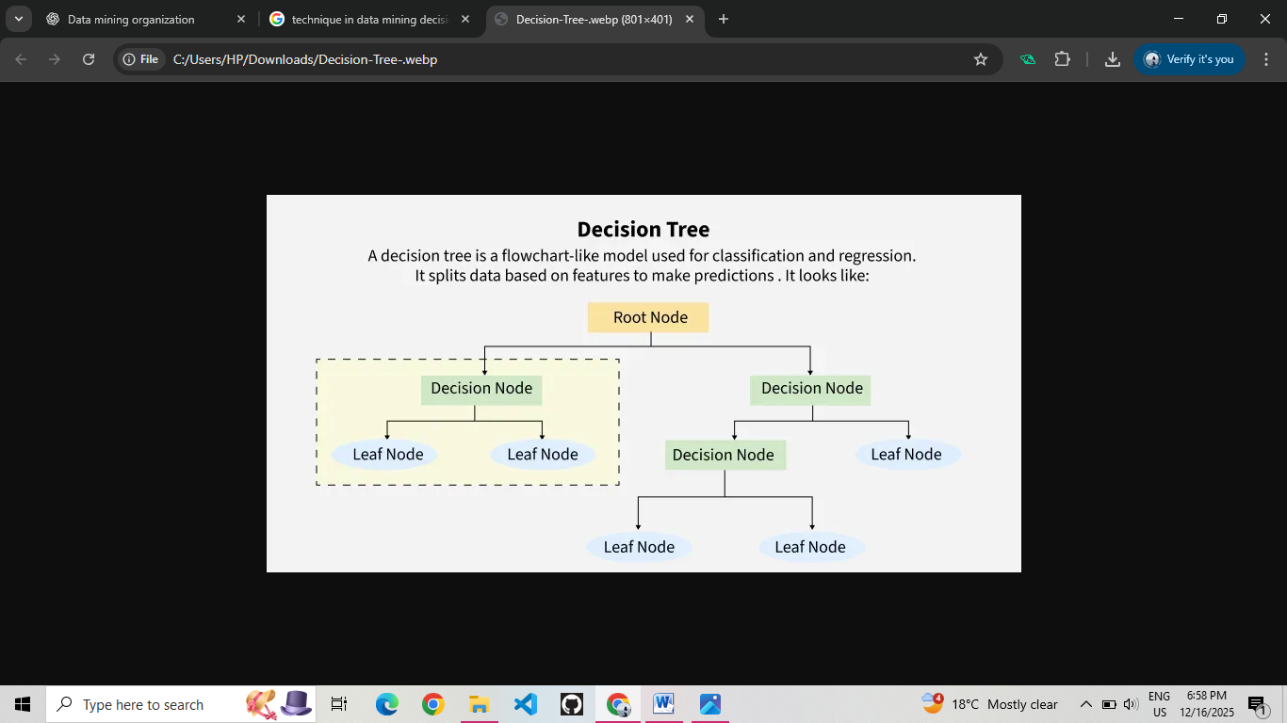

Steps to Build a Decision Tree
- Select the best feature to split the data (using measures like Information Gain or Gini Index).
Use attribute selection measures like:
- Information Gain (IG) – Measures reduction in entropy.
- Gini Index – Measures impurity in the dataset.
- Gain Ratio – Normalizes information gain to account for multiple splits.
- Split the dataset based on the selected feature.
- Create decision nodes and branches for each split.
- Repeat the process for each branch using remaining features.
- Stop when all data is classified or stopping criteria is met.
- Assign the final decision at the leaf nodes.

Applications of Decision Tree
- Medical diagnosis
- Credit risk analysis
- Fraud detection
- Customer segmentation
- Loan approval systems

Advantages of Decision Tree
- Easy to visualize and explain
- Requires minimal data preprocessing
- Handles both types of data
- Fast and efficient for decision-making

Disadvantages of Decision Tree
- Can overfit the data
- Sensitive to small data changes
- Less accurate for complex datasets
- Large trees can become hard to manage
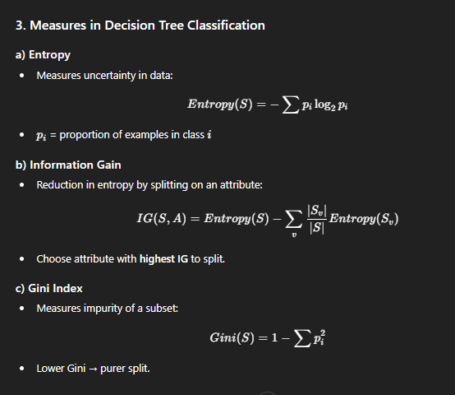

Example Question
Consider the following dataset about whether a customer Buys a Computer based on Age.
Use Entropy and Information Gain to decide which attribute should be the root node of the decision tree.

Given Dataset (Table)
Age | Buys Computer
Young | No
Young | No
Middle | Yes
Old | Yes
Old | Yes
Middle | No

Step 1: Count Yes and No
- Total records = 6
- Yes = 3
- No = 3
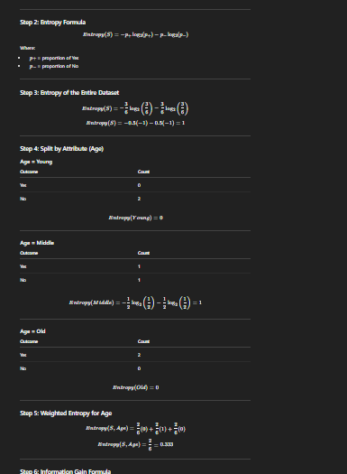

Step 6: Information Gain Formula
IG(S, Age) = Entropy(S) - Entropy(S, Age)

Step 7: Information Gain for Age
IG(S, Age) = 1 - 0.333 = 0.667

Final Answer
- Information Gain of Age = 0.667
- Since this is high, Age is chosen as the root node of the decision tree.

Association Rule Mining
Association rule mining is a data mining technique used to discover interesting relationships, patterns, or associations among a set of items in large datasets. It is widely used in market basket analysis, where the goal is to find items that frequently occur together in transactions.

Association Rules: X Y
- (X) = antecedent (if part)
- (Y) = consequent (then part)
- (X) and (Y) are item sets.
- This means: "If X occurs, Y is likely to occur as well."
Measures used:

a) Support
- Definition: Fraction of transactions that contain both (X) and (Y).
Support(X Y) = Transactions containing both X and Y / Total transactions
Example:
- Bread → Milk
- Support = 3/5 = 0.6 (60%)

b) Confidence
- Definition: Probability that (Y) occurs given (X) occurs.
Confidence(X Y) = Support (X ∪ Y) / Support(X)
Example:
- Bread → Milk
- Confidence = Support(Bread ∪ Milk) / Support(Bread) = 3/4 = 0.75 (75%)
A high confidence means that the rule is reliable.

Steps in Association Rule Mining
- Collect transactions.
- Set minimum support and confidence thresholds.
- Find frequent item sets (using algorithms like Apriori or FP-Growth).
- Generate association rules from frequent item sets.
- Evaluate rules using support, confidence, and lift.

Example of Association Rule Mining
Dataset (Market Basket Example):
Transaction ID | Items Purchased
T1 | Bread, Milk
T2 | Bread, Diaper, Beer, Eggs
T3 | Milk, Diaper, Beer, Cola
T4 | Bread, Milk, Diaper, Beer
T5 | Bread, Milk, Diaper, Cola
Goal: Discover rules like:
- Bread → Milk
- Diaper → Beer
These rules tell us which products are often bought together.

Frequent Item Sets
A frequent item set is a set of items that appears together in the dataset at least as frequently as a specified minimum support.
Steps to Find Frequent Item Sets (using Apriori algorithm):
- Set Minimum Support Threshold (e.g., 60% of transactions).
- Generate Candidate Item Sets: Start with single items, then pairs, triples, etc.
- Count Occurrences: Only keep those item sets that meet the minimum support.
- Iterate: Combine frequent item sets to generate larger sets until no more sets meet the threshold.
Example (Support counts):
Item Set | Support Count | Support (%)
Bread | 4/5 | 80%
Milk | 4/5 | 80%
Bread, Milk | 3/5 | 60%
Diaper, Beer | 3/5 | 60%

Significance of Lift
Lift measures the strength of a rule relative to the expected frequency of (Y) if (X) and (Y) were independent.
Lift(X Y) = Confidence(X Y) / Support(Y)
- Lift = 1: X and Y are independent (no association).
- Lift > 1: Positive association; Y is more likely with X.
- Lift < 1: Negative association; Y is less likely with X.
Example:
- Bread → Milk
- Support(Milk) = 4/5 = 0.8
- Confidence(Bread → Milk) = 0.75
- Lift = 0.75 / 0.8 = 0.9375 → Slight negative correlation
Lift helps evaluate whether the rule adds value beyond random chance.
Sure! Let’s go step by step to describe k-Nearest Neighbors (k-NN) with an example.

k-Nearest Neighbors (k-NN) Algorithm
k-Nearest Neighbors (k-NN) is a supervised machine learning algorithm used for classification and regression. It classifies a new data point based on the majority class of its k nearest neighbors in the feature space.
- Non-parametric: Makes no assumptions about data distribution.
- Lazy learning algorithm: Does not train a model explicitly; it stores the dataset and performs computation during prediction.

Key Concepts
- k: The number of nearest neighbors considered.
- Distance Metric: Used to measure similarity between points. Common metrics include:
  - Euclidean distance (most common)
  - Manhattan distance
  - Minkowski distance
- Majority Voting: The class that appears most frequently among neighbors is assigned to the new point.

Steps of k-NN Classification
- Choose k (number of neighbors).
- Compute distances between the new data point and all points in the training set.
- Sort distances in ascending order.
- Select k nearest neighbors based on smallest distances.
- Vote for the class with the majority among neighbors.
- Assign class to the new data point.

Example
Training Dataset:
Customer | Age | Income | Buy Product
C1 | 22 | 30000 | No
C2 | 25 | 32000 | No
C3 | 28 | 35000 | Yes
C4 | 35 | 40000 | Yes
C5 | 40 | 42000 | Yes
New Customer: Age = 30, Income = 36000
- We want to predict whether they will Buy Product.
- Let’s take k = 3 (3 nearest neighbors).

Step 1: Compute distances (Euclidean)
d = \sqrt{(Age_1 - Age_2)^2 + (Income_1 - Income_2)^2}
- Distance to C1: (\sqrt{(30-22)^2 + (36000-30000)^2}) ≈ large
- Distance to C2: smaller
- Distance to C3: smallest
- Distance to C4: medium
- Distance to C5: larger

Step 2: Select 3 nearest neighbors
- Suppose nearest neighbors are C3 (Yes), C4 (Yes), C2 (No)

Step 3: Majority Voting
- Yes: 2 neighbors
- No: 1 neighbor
Prediction: New customer → Buy Product = Yes

Advantages of k-NN
- Simple and easy to understand.
- No assumptions about data distribution (non-parametric).
- Can work with multi-class problems.

Limitations
- Computationally expensive for large datasets (distance computed for all points).
- Sensitive to irrelevant features and feature scaling.
- Choosing the right k is critical:
  - Small k → noisy predictions
  - Large k → may smooth out boundaries too much

Applications
- Customer classification (buy/not buy).
- Handwriting recognition.
- Medical diagnosis.
- Image and pattern recognition.

1. Data Preprocessing
Data preprocessing is the process of cleaning, transforming, and organizing raw data into a suitable format for analysis and data mining. It ensures data quality and consistency.

Features
- Handles missing values
- Detects and corrects errors or inconsistencies
- Converts data into proper format or structure
- Reduces noise and redundancy
- Prepares data for efficient mining

Techniques
- Data Cleaning: Removing noise, errors, duplicates
- Data Integration: Combining data from multiple sources
- Data Transformation: Normalization, aggregation, generalization
- Data Reduction: Reducing dataset size while maintaining integrity
- Data Discretization: Converting continuous data into intervals

Types
- Cleaning: Handling missing, noisy, and inconsistent data
- Transformation: Normalization, aggregation, smoothing
- Integration: Combining multiple datasets
- Reduction: Dimension reduction or instance reduction

Steps in Data Preprocessing
- Data Cleaning: Handle missing values, outliers, and errors
- Data Integration: Merge data from multiple sources
- Data Transformation: Normalize or aggregate data
- Data Reduction: Reduce data size without losing important information
- Data Discretization / Feature Selection: Convert continuous to categorical or select important attributes

Importance in Data Mining
- Ensures high-quality input data for mining
- Reduces errors and noise, improving model accuracy
- Saves computational resources
- Enables better pattern detection

2. Data Integration
Data integration is the process of combining data from multiple heterogeneous sources into a single, unified view. It ensures that data from different formats, structures, or sources can be analyzed together in a coherent way.

Features
- Combines data from multiple sources
- Resolves data inconsistencies
- Provides a unified data view
- Supports both structured and unstructured data
- Enables seamless access for analysis

Techniques
- ETL (Extract, Transform, Load): Extract data from sources, transform it to the required format, and load into a target database
- Data Warehousing: Centralized storage of integrated data
- Virtual Integration / Federated Database: Querying data without physically moving it
- Schema Integration: Aligning different database schemas into a unified schema

Types
- Manual Integration: Done by humans through scripts or queries
- Semi-automatic Integration: Uses tools with some human intervention
- Automatic Integration: Fully automated with minimal human effort

Steps in Data Integration
- Data Discovery: Identify all relevant data sources
- Data Extraction: Extract data from different sources
- Data Cleaning: Remove inconsistencies and duplicates
- Data Transformation: Convert data into a common format
- Data Loading: Load data into a target system (warehouse or database)
- Data Validation: Ensure the integrated data is accurate and consistent

Importance in Data Mining
- Provides a complete dataset for analysis
- Reduces redundancy and inconsistency in data
- Improves accuracy of data mining models
- Enables holistic insights from multiple sources

3. Data Transformation
Data transformation is the process of converting data from one format or structure into another to make it suitable for analysis and data mining. This process is essential to improve data quality and compatibility.

Features
- Converts data into the desired format
- Standardizes data values and units
- Normalizes or aggregates data for analysis
- Reduces data redundancy
- Prepares data for efficient mining

Common Data Transformation Techniques
- Data Normalization: Scales data to a common range
- Standardization: Adjusts data to have zero mean and unit variance
- Discretization: Converts continuous data into discrete categories
- Data Aggregation: Summarizes data using totals or averages
- Generalization: Replacing low-level values with higher-level concepts (e.g., exact age → age group)
- Attribute Construction: Creating new attributes from existing ones
- Smoothing: Removing noise from data

Types
- Simple Transformation: Basic formatting, unit conversion, or standardization
- Complex Transformation: Involves aggregation, feature engineering, and creating derived attributes

Steps in Data Transformation
- Data Profiling: Understand the data structure and content
- Data Cleaning: Handle missing values, outliers, and errors
- Transformation Selection: Decide the appropriate technique (normalization, aggregation, etc.)
- Data Conversion: Apply transformations to the dataset
- Validation: Verify that the transformed data maintains integrity and consistency

Importance in Data Mining
- Improves accuracy and performance of data mining models
- Makes heterogeneous data compatible for mining
- Reduces noise and redundancy
- Ensures efficient processing and storage
- Enables better pattern discovery

4. Data Reduction
Data reduction is the process of reducing the volume of data while maintaining its integrity and essential patterns. It makes data mining more efficient.

Features
- Reduces data size and storage requirements
- Maintains information content
- Enhances processing speed
- Improves efficiency of mining algorithms

Techniques
- Dimensionality Reduction: Reducing the number of attributes (e.g., Principal Component Analysis – PCA)
- Data Compression: Representing data in compressed formats
- Numerosity Reduction: Using aggregation, histograms, sampling
- Discretization: Converting continuous attributes into fewer intervals

Types
- Attribute Reduction: Reducing the number of features or variables
- Record Reduction: Reducing the number of data points via sampling or aggregation
- Data Compression: Storing data in compressed formats

Steps in Data Reduction
- Identify redundant or irrelevant attributes
- Apply dimensionality reduction techniques
- Use aggregation, sampling, or compression
- Validate reduced data for accuracy and patterns

Importance in Data Mining
- Makes data mining faster and less resource-intensive
- Reduces complexity of models
- Helps focus on significant patterns
- Enables efficient storage and retrieval

